**MP2 Documentation**

**Home Page:**

This page asks and validates the name of the student with his/her Year & Section for the vote page.

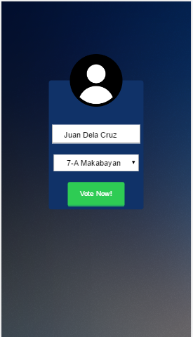

**Vote Page:**

The vote page given to the student is based on the class he/she is in to. The page lets the student vote for the candidates and submits the vote.

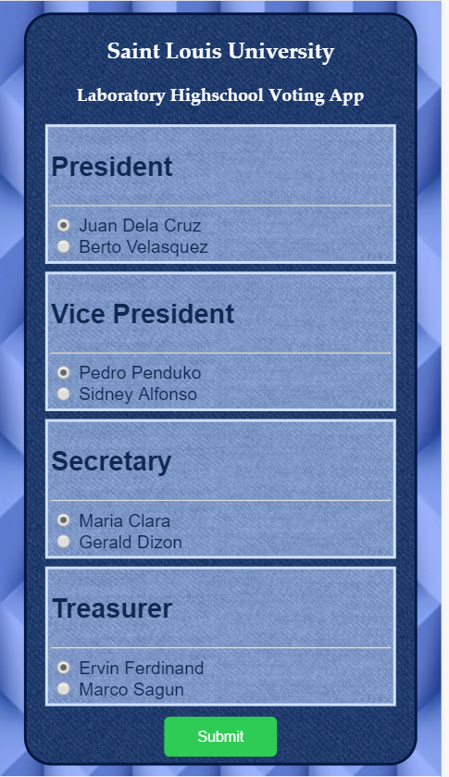

**Result Page:**

After the student is done submitting his/her vote a prompt will appear that he/she had indeed submitted a vote which the Teacher application will compute and generate report.

